https://jira.tcsbank.ru/browse/IN-404
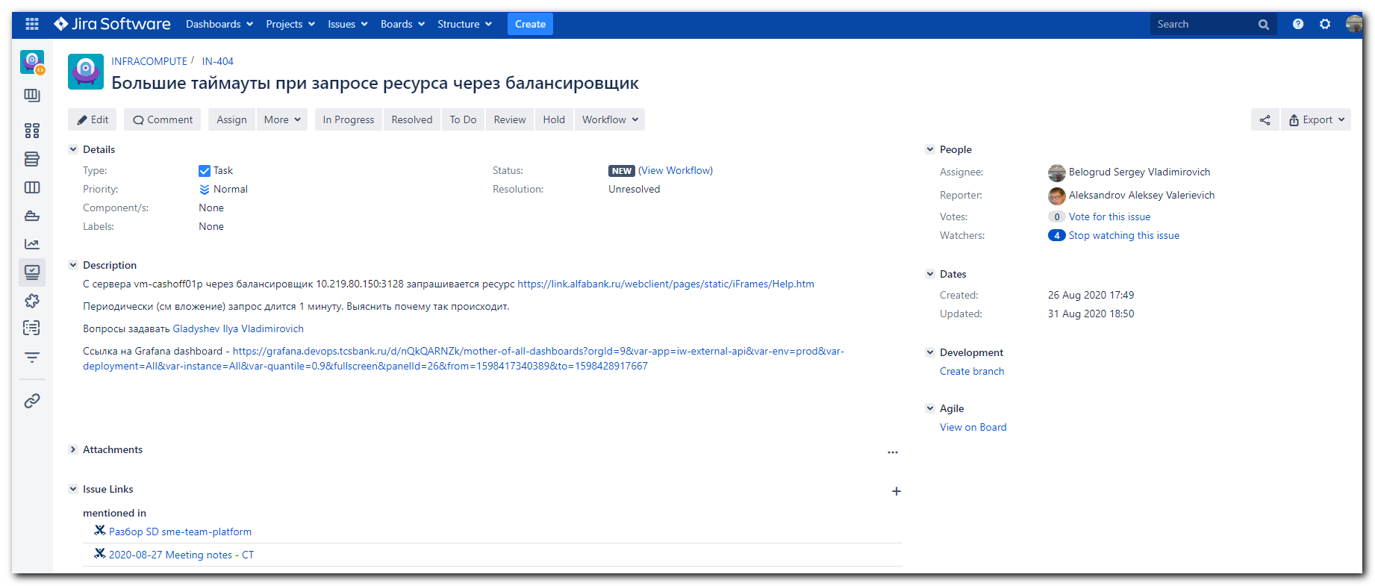
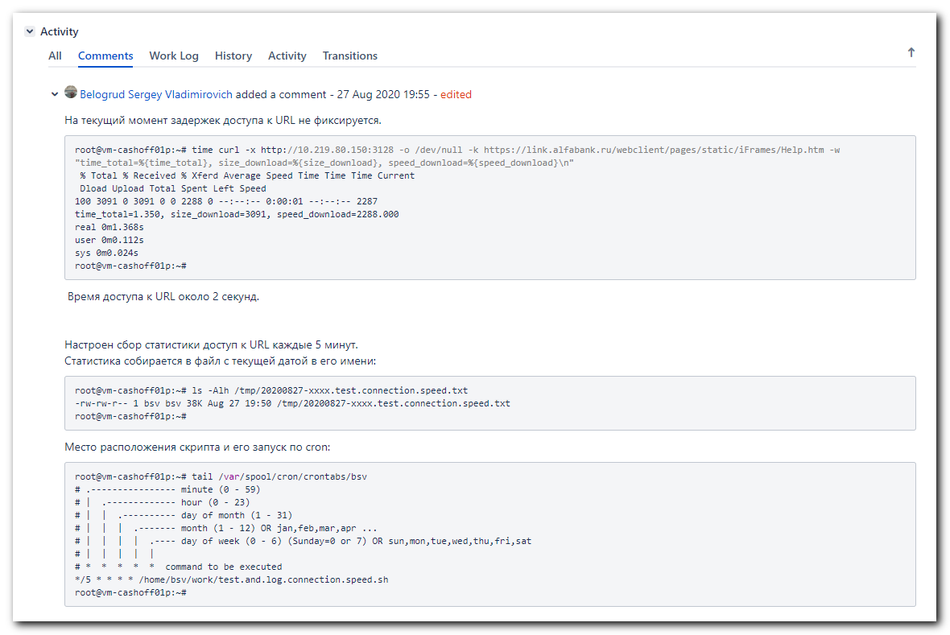
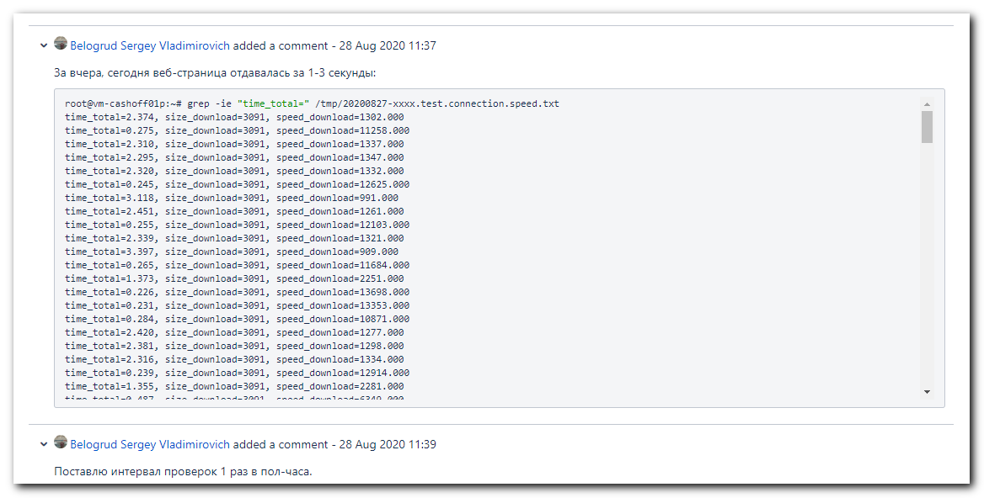
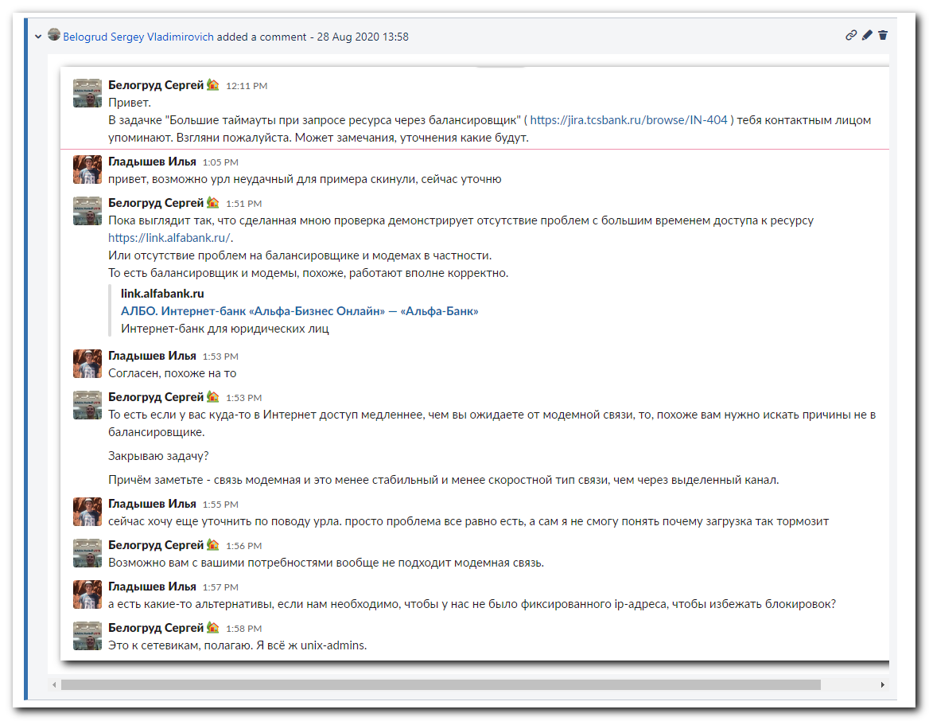
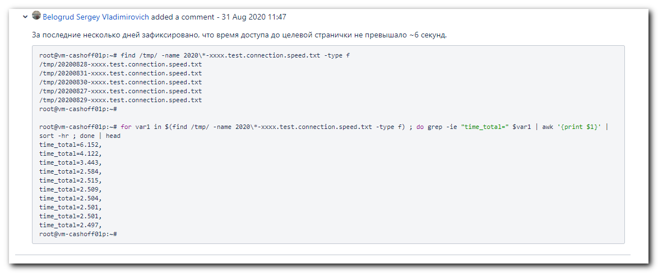
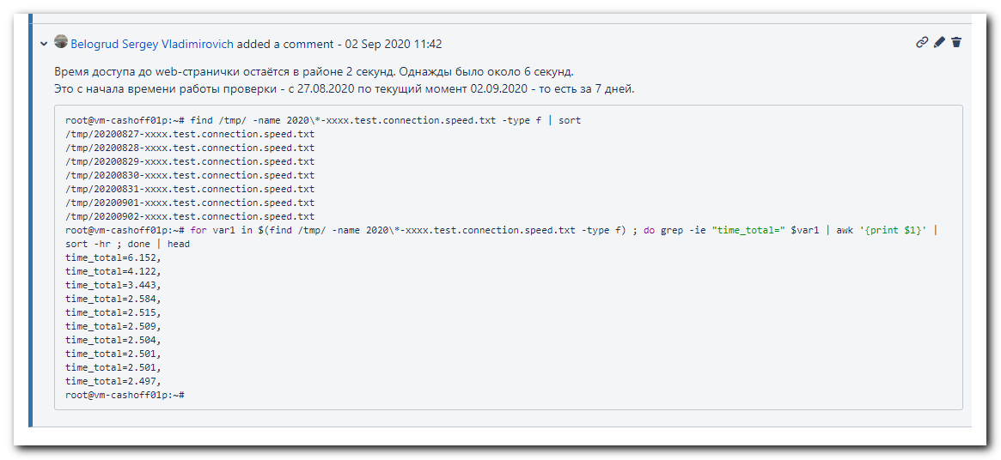

................................................................................
#
# Here I tested access to target web-page from my workstation. It's thrue cable access to the Internet.

[s.belogrud@TCS4357]# time curl -O -k https://link.alfabank.ru/webclient/pages/static/iFrames/Help.htm
% Total % Received % Xferd Average Speed Time Time Time Current
Dload Upload Total Spent Left Speed
100 3091 0 3091 0 0 42930 0 --:--:-- --:--:-- --:--:-- 42930
real 0m 0.63s
user 0m 0.09s
sys 0m 0.38s
[s.belogrud@TCS4357]#

[s.belogrud@TCS4357]# time curl https://link.alfabank.ru/webclient/pages/static/iFrames/Help.htm
<html>

<head>

<link rel="stylesheet" href="style.css">
<link rel="shortcut icon" href="favicon.ico" type="image/x-icon">

<meta http-equiv=Content-Type content="text/html; charset=UTF-8">
<title>РђР»СЊС„Р°-Р‘РёР·РЅРµСЃ РћРЅР»Р°Р№РЅ: РЎРїСЂР°РІРєР°</title>
</head>

<body lang=RU link=blue vlink=purple>

<body>
<table class="head_gray"
width="100%">
<tbody>
<tr>
<td align="center" width="34%" style="body"> <h1><strong>РЎРїСЂР°РІРєР° вЂ” РћС‚РІРµС‚С‹ РЅР° С‡Р°СЃС‚Рѕ Р·Р°РґР°РІР°РµРјС‹Рµ РІРѕРїСЂРѕСЃС‹ </strong> </h1></td>

</tr>
</tbody>
</table>
<br>

<h2><a name="_Toc_0_01">РЎРѕРґРµСЂР¶Р°РЅРёРµ</a></h2>

<h3><a class=menu href="Help_1.htm"><span>1.&nbsp;&nbsp;&nbsp;</span> Р’РѕР·РјРѕР¶РЅРѕСЃС‚Рё СЃРёСЃС‚РµРјС‹ РђР»СЊС„Р°-Р‘РёР·РЅРµСЃ РћРЅР»Р°Р№РЅ</a></h3>

<h3><a class=menu href="Help_2.htm"><span>2.&nbsp;&nbsp;&nbsp;</span> РўСЂРµР±РѕРІР°РЅРёСЏ
Рє РїСЂРѕРіСЂР°РјРјРЅРѕРјСѓ Рё Р°РїРїР°СЂР°С‚РЅРѕРјСѓ РѕР±РµСЃРїРµС‡РµРЅРёСЋ </a></h3>

<h3><a class=menu href="Help_3.htm"><span>3.&nbsp;&nbsp;&nbsp;</span> РќР°С‡Р°Р»Рѕ СЂР°Р±РѕС‚С‹: РґРѕСЃС‚СѓРї, Р»РѕРіРёРЅ, РїР°СЂРѕР»Рё</a></h3>

<h3><a class=menu href="Help_4.htm"><span>4.&nbsp;&nbsp;&nbsp;</span> РџР»Р°С‚РµР¶РЅС‹Рµ РїРѕСЂСѓС‡РµРЅРёСЏ</a></h3>

<h3><a class=menu href="Help_5.htm"><span>5.&nbsp;&nbsp;&nbsp;</span> РЎС‚Р°С‚СѓСЃС‹ РїР»Р°С‚РµР¶РЅС‹С…
РїРѕСЂСѓС‡РµРЅРёР№ </a></h3>

<h3><a class=menu href="Help_6.htm"><span>6.&nbsp;&nbsp;&nbsp;</span> РРјРїРѕСЂС‚</a></h3>

<h3><a class=menu href="Help_7.htm"><span>7.&nbsp;&nbsp;&nbsp;</span> Р РµРµСЃС‚СЂС‹ РїР»Р°С‚РµР¶РЅС‹С…
РїРѕСЂСѓС‡РµРЅРёР№ </a></h3>

<h3><a class=menu href="Help_8.htm"><span>8.&nbsp;&nbsp;&nbsp;</span> РљРѕРЅС‚СЂР°РіРµРЅС‚С‹ </a></h3>

<h3><a class=menu href="Help_9.htm"><span>9.&nbsp;&nbsp;&nbsp;</span> РџРёСЃСЊРјР°</a></h3>

<h3><a class=menu href="Help_10.htm"><span>10.&nbsp;</span> Р’С‹РїРёСЃРєРё </a></h3>

<h3><a class=menu href="Help_11.htm"><span>11.&nbsp;</span> SMS Рё Email-СѓРІРµРґРѕРјР»РµРЅРёСЏ </a></h3>

<h3><a class=menu href="Help_12.htm"><span>12.&nbsp;</span> РњРѕР±РёР»СЊРЅС‹Р№ Р±Р°РЅРє РђР»СЊС„Р°-Р‘РёР·РЅРµСЃ-РњРѕР±Р°Р№Р» </a></h3>

<h3><a class=menu href="Help_13.htm"><span>13.&nbsp;</span> РћР±Р»Р°С‡РЅР°СЏ Р±СѓС…РіР°Р»С‚РµСЂРёСЏ </a></h3>

<h3><a class=menu href="Help_14.htm"><span>14.&nbsp;</span> Р’Р°Р»СЋС‚РЅС‹Рµ РґРѕРєСѓРјРµРЅС‚С‹ </a></h3>

<h3><a class=menu href="Help_15.htm"><span>15.&nbsp;</span> Р—Р°СЏРІР»РµРЅРёСЏ РЅР° СЃРЅСЏС‚РёРµ РЅР°Р»РёС‡РЅС‹С… </a></h3>

<h3><a class=menu href="Help_16.htm"><span>16.&nbsp;</span> РљРѕРЅРІРµСЂС‚Р°С†РёСЏ </a></h3>

<h3><a class=menu href="Help_17.htm"><span>17.&nbsp;</span> Р‘Р°РЅРєРѕРІСЃРєРёРµ РєР°СЂС‚С‹ </a></h3>

<h3><a class=menu href="Help_18.htm"><span>18.&nbsp;</span> РЁР°Р±Р»РѕРЅС‹ </a></h3>

<h3><a class=menu href="Help_19.htm"><span>19.&nbsp;</span> Р‘Р­РЎРџ </a></h3>

<h3><a class=menu href="Help_20.htm"><span>20.&nbsp;</span> Р”СЂСѓРіРёРµ РІРѕРїСЂРѕСЃС‹ </a></h3>

<h3><a class=menu href="Help_21.htm"><span>21.&nbsp;</span> РљСЂРёРїС‚РѕРіСЂР°С„РёСЏ </a></h3>

</div>
</tbody>
</body>

</html>
real 0m 4.12s
user 0m 0.09s
sys 0m 0.42s
[s.belogrud@TCS4357]#

................................................................................

root@vm-cashoff01p:~# time curl -O -k https://link.alfabank.ru/webclient/pages/static/iFrames/Help.htm
% Total % Received % Xferd Average Speed Time Time Time Current
Dload Upload Total Spent Left Speed
0 0 0 0 0 0 0 0 --:--:-- 0:00:36 --:--:-- 0

real 0m36.814s
user 0m0.012s
sys 0m0.000s
root@vm-cashoff01p:~# time curl -x http://10.219.80.150:3128 -O -k https://link.alfabank.ru/webclient/pages/static/iFrames/Help.htm
% Total % Received % Xferd Average Speed Time Time Time Current
Dload Upload Total Spent Left Speed
100 3091 0 3091 0 0 1904 0 --:--:-- 0:00:01 --:--:-- 1904

real 0m1.641s
user 0m0.140s
sys 0m0.084s
root@vm-cashoff01p:~# time curl -v -x http://10.219.80.150:3128 -O -k https://link.alfabank.ru/webclient/pages/static/iFrames/Help.htm
* Trying 10.219.80.150...
% Total % Received % Xferd Average Speed Time Time Time Current
Dload Upload Total Spent Left Speed
0 0 0 0 0 0 0 0 --:--:-- --:--:-- --:--:-- 0* Connected to 10.219.80.150 (10.219.80.150) port 3128 (#0)
* Establish HTTP proxy tunnel to link.alfabank.ru:443
> CONNECT link.alfabank.ru:443 HTTP/1.1
> Host: link.alfabank.ru:443
> User-Agent: curl/7.47.0
> Proxy-Connection: Keep-Alive
>
< HTTP/1.1 200 Connection established
<
* Proxy replied OK to CONNECT request
* found 151 certificates in /etc/ssl/certs/ca-certificates.crt
* found 608 certificates in /etc/ssl/certs
* ALPN, offering http/1.1
* SSL connection using TLS1.2 / ECDHE_RSA_AES_128_GCM_SHA256
* server certificate verification SKIPPED
* server certificate status verification SKIPPED
* common name: link.alfabank.ru (matched)
* server certificate expiration date OK
* server certificate activation date OK
* certificate public key: RSA
* certificate version: #3
* subject: businessCategory=Private Organization,jurisdictionOfIncorporationCountryName=RU,serialNumber=1027700067328,C=RU,L=Moscow,O=AO Alfa-Bank,CN=link.alfabank.ru
* start date: Fri, 29 May 2020 00:00:00 GMT
* expire date: Fri, 06 Nov 2020 12:00:00 GMT
* issuer: C=US,O=DigiCert Inc,OU=www.digicert.com,CN=Thawte EV RSA CA 2018
* compression: NULL
* ALPN, server did not agree to a protocol
> GET /webclient/pages/static/iFrames/Help.htm HTTP/1.1
> Host: link.alfabank.ru
> User-Agent: curl/7.47.0
> Accept: */*
>
< HTTP/1.1 200 OK
< Expires: Thu, 27 Aug 2020 14:36:39 GMT
< Cache-Control: public,max-age=-1, must-revalidate
< Last-Modified: Tue, 11 Aug 2020 18:20:22 GMT
< Content-Type: text/html; charset=UTF-8
< Date: Thu, 27 Aug 2020 14:36:39 GMT
< Content-Language: ru-US
< Set-Cookie: BIGipServer~CORP~link_pool=!kHU4wEYUJxz0HK2KAdcWGWcHRWF8AchaQ/ufYyBIGBxPyQhk+JK1sSK8n8QAl/wTXvsv9HSB43uXA4j0ranoCDkmfnIwhVL7fQLBrNRXlQ==; path=/; Httponly; Secure
< X-Frame-Options: SAMEORIGIN
< access-control-allow-origin: https://business.auth.alfabank.ru
< Vary: Accept-Encoding
< Transfer-Encoding: chunked
<
{ [996 bytes data]
100 3091 0 3091 0 0 10122 0 --:--:-- --:--:-- --:--:-- 10134
* Connection #0 to host 10.219.80.150 left intact

real 0m0.324s
user 0m0.092s
sys 0m0.052s
root@vm-cashoff01p:~#

................................................................................

root@vm-cashoff01p:~# time curl -v -x http://proxy.tcsbank.ru:8090 -O -k https://link.alfabank.ru/webclient/pages/static/iFrames/Help.htm
% Total % Received % Xferd Average Speed Time Time Time Current
Dload Upload Total Spent Left Speed
0 0 0 0 0 0 0 0 --:--:-- 0:00:01 --:--:-- 0* Trying 10.218.11.49...
0 0 0 0 0 0 0 0 --:--:-- 0:00:02 --:--:-- 0* connect to 10.218.11.49 port 8090 failed: Connection refused
* Trying 10.218.11.50...
* connect to 10.218.11.50 port 8090 failed: Connection refused
* Trying 10.218.11.51...
* connect to 10.218.11.51 port 8090 failed: Connection refused
* Trying 10.218.6.48...
* connect to 10.218.6.48 port 8090 failed: Connection refused
* Trying 10.218.6.49...
* connect to 10.218.6.49 port 8090 failed: Connection refused
* Trying 10.218.6.50...
* connect to 10.218.6.50 port 8090 failed: Connection refused
* Trying 10.218.6.51...
* connect to 10.218.6.51 port 8090 failed: Connection refused
* Trying 10.218.11.48...
* connect to 10.218.11.48 port 8090 failed: Connection refused
* Failed to connect to proxy.tcsbank.ru port 8090: Connection refused
* Closing connection 0
curl: (7) Failed to connect to proxy.tcsbank.ru port 8090: Connection refused

real 0m2.524s
user 0m0.004s
sys 0m0.004s
root@vm-cashoff01p:~#

................................................................................
root@vm-cashoff01p:~# man curl
root@vm-cashoff01p:~# time curl --trace-time --trace-ascii ./trace.txt -x http://10.219.80.150:3128 -O -k https://link.alfabank.ru/webclient/pages/static/iFrames/Help.htm
% Total % Received % Xferd Average Speed Time Time Time Current
Dload Upload Total Spent Left Speed
100 3091 0 3091 0 0 910 0 --:--:-- 0:00:03 --:--:-- 910

real 0m3.414s
user 0m0.096s
sys 0m0.040s
root@vm-cashoff01p:~# less trace.txt
root@vm-cashoff01p:~#
................................................................................
root@vm-cashoff01p:~# man curl
root@vm-cashoff01p:~# curl -s -S -x http://10.219.80.150:3128 -o /dev/null -k https://link.alfabank.ru/webclient/pages/static/iFrames/Help.htm >> ./curl.log 2>>curl.err.log
root@vm-cashoff01p:~# cat curl.log
root@vm-cashoff01p:~# cat curl.err.log
root@vm-cashoff01p:~# curl -s -S -x http://10.219.80.150:3128 -O -k https://link.alfabank.ru/webclient/pages/static/iFrames/Help.htm >> ./curl.log 2>>curl.err.log
root@vm-cashoff01p:~# cat curl.log
root@vm-cashoff01p:~# cat curl.err.log
root@vm-cashoff01p:~#
................................................................................
root@vm-cashoff01p:~# curl -x http://10.219.80.150:3128 -O -k https://link.alfabank.ru/webclient/pages/static/iFrames/Help.htm >> ./curl.log 2>>curl.err.log
root@vm-cashoff01p:~# cat curl.log
root@vm-cashoff01p:~# cat curl.err.log
% Total % Received % Xferd Average Speed Time Time Time Current
Dload Upload Total Spent Left Speed
100 3091 0 3091 0 0 1298 0 --:--:-- 0:00:02 --:--:-- 1298
root@vm-cashoff01p:~# head Help.htm
................................................................................

root@vm-cashoff01p:~# curl --trace-time --trace-ascii curl.trace.log -x http://10.219.80.150:3128 -O -k https://link.alfabank.ru/webclient/pages/static/iFrames/Help.htm >curl.log 2>curl.err.log
root@vm-cashoff01p:~# cat curl.log ; cat curl.err.log
% Total % Received % Xferd Average Speed Time Time Time Current
Dload Upload Total Spent Left Speed
100 3091 0 3091 0 0 2281 0 --:--:-- 0:00:01 --:--:-- 2282
root@vm-cashoff01p:~# less curl.trace.log
root@vm-cashoff01p:~#
root@vm-cashoff01p:~#

................................................................................

# Here creates output file named as Help.htm
root@vm-cashoff01p:~# curl --trace-time --trace-ascii curl.trace.log -x http://10.219.80.150:3128 -O -k https://link.alfabank.ru/webclient/pages/static/iFrames/Help.htm
>curl.log 2>curl.err.log

# Here is no output file.
root@vm-cashoff01p:~# curl --trace-time --trace-ascii curl.trace.log -x http://10.219.80.150:3128 -o /dev/null -k https://link.alfabank.ru/webclient/pages/static/iFrames/Help.htm 2>curl.err.log

# Here creates three output file: curl.log - it's same as Help.htm, curl.trace.log, curl.err.log.
root@vm-cashoff01p:~# curl --trace-time --trace-ascii curl.trace.log -x http://10.219.80.150:3128 -k https://link.alfabank.ru/webclient/pages/static/iFrames/Help.htm 2>curl.err.log

root@vm-cashoff01p:~# curl -s -S -x http://10.219.80.150:3128 -o /dev/null -k https://link.alfabank.ru/webclient/pages/static/iFrames/Help.htm -w "%{time_total},%{size_download},%{speed_download}\n" >> curl.stats.log
root@vm-cashoff01p:~# cat curl.stats.log
1.373,3091,2251.000
root@vm-cashoff01p:~#

................................................................................

root@vm-cashoff01p:~# curl --trace-time --trace-ascii curl.trace.log -x http://10.219.80.150:3128 -o /dev/null -k https://link.alfabank.ru/webclient/pages/static/iFrames/Help.htm -w "%{time_total},%{size_download},%{speed_download}\n" >curl.log 2>curl.err.log
root@vm-cashoff01p:~# cat curl.log
1.343,3091,2301.000
root@vm-cashoff01p:~# head curl.err.log
% Total % Received % Xferd Average Speed Time Time Time Current
Dload Upload Total Spent Left Speed
100 3091 0 3091 0 0 2301 0 --:--:-- 0:00:01 --:--:-- 2301
root@vm-cashoff01p:~# head curl.trace.log
18:45:31.602521 == Info: Trying 10.219.80.150...
18:45:31.603913 == Info: Connected to 10.219.80.150 (10.219.80.150) port 3128 (#0)
18:45:31.603926 == Info: Establish HTTP proxy tunnel to link.alfabank.ru:443
18:45:31.603965 => Send header, 124 bytes (0x7c)
0000: CONNECT link.alfabank.ru:443 HTTP/1.1
0027: Host: link.alfabank.ru:443
0043: User-Agent: curl/7.47.0
005c: Proxy-Connection: Keep-Alive
007a:
18:45:31.658265 <= Recv header, 37 bytes (0x25)
root@vm-cashoff01p:~#

................................................................................

root@vm-cashoff01p:~# time curl -x http://10.219.80.150:3128 -o /dev/null -k https://link.alfabank.ru/webclient/pages/static/iFrames/Help.htm -w "time_total=%{time_total}, size_download=%{size_download}, speed_download=%{speed_download}\n"
% Total % Received % Xferd Average Speed Time Time Time Current
Dload Upload Total Spent Left Speed
100 3091 0 3091 0 0 2288 0 --:--:-- 0:00:01 --:--:-- 2287
time_total=1.350, size_download=3091, speed_download=2288.000

real 0m1.368s
user 0m0.112s
sys 0m0.024s
root@vm-cashoff01p:~#

root@vm-cashoff01p:~# cat ~bsv/work/test.and.log.connection.speed.sh
#!/bin/bash

file_summary_statistics="/tmp/$(date +%Y%m%d-xxxx).test.connection.speed.txt"
curl_trace_log="/tmp/curl.trace.log"
curl_statistic_log="/tmp/curl.statistic.log"
curl_progress_log="/tmp/curl.progress.log"

timeout 3m curl --trace-time --trace-ascii ${curl_trace_log} -x http://10.219.80.150:3128 -o /dev/null -k https://link.alfabank.ru/webclient/pages/static/iFrames/Help.htm -w "time_total=%{time_total}, size_download=%{size_download}, speed_download=%{speed_download}\n" >${curl_statistic_log} 2>${curl_progress_log}

echo "#### $(date) ####" >> ${file_summary_statistics}

echo -e "\n" >> ${file_summary_statistics}
cat ${curl_statistic_log} >> ${file_summary_statistics}

echo -e "\n" >> ${file_summary_statistics}
sed -e "s/\r/\n/g" ${curl_progress_log} >> ${file_summary_statistics}

echo -e "\n" >> ${file_summary_statistics}
cat ${curl_trace_log} >> ${file_summary_statistics}

echo "#### $(date) ####" >> ${file_summary_statistics}

rm ${curl_statistic_log} ${curl_progress_log} ${curl_trace_log}

root@vm-cashoff01p:~#

root@vm-cashoff01p:~# cp work/test.and.log.connection.speed.sh /tmp/
root@vm-cashoff01p:~# su - bsv
bsv@vm-cashoff01p:~$ mkdir work
bsv@vm-cashoff01p:~$ cp /tmp/test.and.log.connection.speed.sh work/
bsv@vm-cashoff01p:~$ ls -Alh /home/bsv/work/test.and.log.connection.speed.sh
-rwxr-xr-x 1 bsv bsv 1020 Aug 27 19:29 /home/bsv/work/test.and.log.connection.speed.sh
bsv@vm-cashoff01p:~$ logout
root@vm-cashoff01p:~# EDITOR=vim crontab -e -u bsv
crontab: installing new crontab
root@vm-cashoff01p:~# rm /tmp/20200827-xxxx.test.connection.speed.txt
root@vm-cashoff01p:~# ls -Alh /var/spool/cron/crontabs/
total 12K
-rw------- 1 bsv crontab 1.6K Aug 27 19:31 bsv
-rw------- 1 ext.akrokhotin crontab 1.2K Sep 7 2018 ext.akrokhotin
-rw------- 1 root crontab 443 Feb 9 2018 root
root@vm-cashoff01p:~#

root@vm-cashoff01p:~# ls -Alh /tmp/2020*
-rw-rw-r-- 1 bsv bsv 15K Aug 27 19:35 /tmp/20200827-xxxx.test.connection.speed.txt
root@vm-cashoff01p:~# tail -f /var/log/syslog | grep -ie cron
Aug 27 19:35:01 vm-cashoff01p CRON[4509]: (root) CMD (command -v debian-sa1 > /dev/null && debian-sa1 1 1)
Aug 27 19:35:01 vm-cashoff01p CRON[4510]: (bsv) CMD (/home/bsv/work/test.and.log.connection.speed.sh)
Aug 27 19:40:01 vm-cashoff01p CRON[4837]: (bsv) CMD (/home/bsv/work/test.and.log.connection.speed.sh)

root@vm-cashoff01p:~# ls -Alh /tmp/2020*
-rw-rw-r-- 1 bsv bsv 23K Aug 27 19:40 /tmp/20200827-xxxx.test.connection.speed.txt
root@vm-cashoff01p:~#
................................................................................

root@vm-cashoff01p:~# grep -ie "time_total=" /tmp/20200827-xxxx.test.connection.speed.txt
time_total=2.374, size_download=3091, speed_download=1302.000
time_total=0.275, size_download=3091, speed_download=11258.000
time_total=2.310, size_download=3091, speed_download=1337.000
time_total=2.295, size_download=3091, speed_download=1347.000
time_total=2.320, size_download=3091, speed_download=1332.000
time_total=0.245, size_download=3091, speed_download=12625.000
time_total=3.118, size_download=3091, speed_download=991.000
time_total=2.451, size_download=3091, speed_download=1261.000
time_total=0.255, size_download=3091, speed_download=12103.000
time_total=2.339, size_download=3091, speed_download=1321.000
time_total=3.397, size_download=3091, speed_download=909.000
time_total=0.265, size_download=3091, speed_download=11684.000
time_total=1.373, size_download=3091, speed_download=2251.000
time_total=0.226, size_download=3091, speed_download=13698.000
time_total=0.231, size_download=3091, speed_download=13353.000
time_total=0.284, size_download=3091, speed_download=10871.000
time_total=2.420, size_download=3091, speed_download=1277.000
time_total=2.381, size_download=3091, speed_download=1298.000
time_total=2.316, size_download=3091, speed_download=1334.000
time_total=0.239, size_download=3091, speed_download=12914.000
time_total=1.355, size_download=3091, speed_download=2281.000
time_total=0.487, size_download=3091, speed_download=6349.000
time_total=2.586, size_download=3091, speed_download=1195.000
time_total=2.623, size_download=3091, speed_download=1178.000
time_total=1.351, size_download=3091, speed_download=2288.000
time_total=2.754, size_download=3091, speed_download=1122.000
time_total=2.437, size_download=3091, speed_download=1268.000
time_total=1.268, size_download=3091, speed_download=2437.000
time_total=0.277, size_download=3091, speed_download=11166.000
time_total=2.334, size_download=3091, speed_download=1324.000
time_total=2.435, size_download=3091, speed_download=1269.000
time_total=2.380, size_download=3091, speed_download=1298.000
time_total=2.315, size_download=3091, speed_download=1335.000
time_total=1.458, size_download=3091, speed_download=2119.000
time_total=0.220, size_download=3091, speed_download=14042.000
time_total=1.417, size_download=3091, speed_download=2181.000
time_total=0.257, size_download=3091, speed_download=12026.000
time_total=0.239, size_download=3091, speed_download=12946.000
time_total=2.361, size_download=3091, speed_download=1309.000
time_total=2.435, size_download=3091, speed_download=1269.000
time_total=1.311, size_download=3091, speed_download=2358.000
time_total=2.371, size_download=3091, speed_download=1303.000
time_total=2.366, size_download=3091, speed_download=1306.000
time_total=0.252, size_download=3091, speed_download=12249.000
time_total=2.394, size_download=3091, speed_download=1291.000
time_total=2.336, size_download=3091, speed_download=1323.000
time_total=2.282, size_download=3091, speed_download=1354.000
time_total=1.402, size_download=3091, speed_download=2204.000
time_total=0.281, size_download=3091, speed_download=10992.000
time_total=2.339, size_download=3091, speed_download=1321.000
time_total=2.477, size_download=3091, speed_download=1248.000
time_total=0.268, size_download=3091, speed_download=11516.000
time_total=0.230, size_download=3091, speed_download=13411.000
time_total=2.442, size_download=3091, speed_download=1265.000
root@vm-cashoff01p:~# grep -ie "time_total=" /tmp/20200828-xxxx.test.connection.speed.txt
time_total=2.497, size_download=3091, speed_download=1237.000
time_total=2.306, size_download=3091, speed_download=1340.000
time_total=0.251, size_download=3091, speed_download=12296.000
time_total=2.302, size_download=3091, speed_download=1342.000
time_total=2.299, size_download=3091, speed_download=1344.000
time_total=0.213, size_download=3091, speed_download=14499.000
time_total=2.501, size_download=3091, speed_download=1235.000
time_total=2.463, size_download=3091, speed_download=1255.000
time_total=0.231, size_download=3091, speed_download=13377.000
time_total=1.684, size_download=3091, speed_download=1835.000
time_total=2.386, size_download=3091, speed_download=1295.000
time_total=1.361, size_download=3091, speed_download=2271.000
time_total=0.644, size_download=3091, speed_download=4802.000
time_total=2.427, size_download=3091, speed_download=1273.000
time_total=2.454, size_download=3091, speed_download=1259.000
time_total=0.220, size_download=3091, speed_download=14060.000
time_total=1.399, size_download=3091, speed_download=2210.000
time_total=1.298, size_download=3091, speed_download=2381.000
time_total=2.299, size_download=3091, speed_download=1344.000
time_total=1.441, size_download=3091, speed_download=2144.000
time_total=2.501, size_download=3091, speed_download=1235.000
time_total=0.293, size_download=3091, speed_download=10540.000
time_total=2.316, size_download=3091, speed_download=1334.000
time_total=0.298, size_download=3091, speed_download=10373.000
time_total=0.333, size_download=3091, speed_download=9292.000
time_total=1.290, size_download=3091, speed_download=2396.000
time_total=1.335, size_download=3091, speed_download=2314.000
time_total=0.209, size_download=3091, speed_download=14800.000
time_total=0.264, size_download=3091, speed_download=11696.000
time_total=1.315, size_download=3091, speed_download=2350.000
time_total=2.372, size_download=3091, speed_download=1303.000
time_total=0.306, size_download=3091, speed_download=10115.000
time_total=2.421, size_download=3091, speed_download=1276.000
time_total=0.211, size_download=3091, speed_download=14624.000
time_total=0.257, size_download=3091, speed_download=12008.000
time_total=0.335, size_download=3091, speed_download=9232.000
time_total=2.367, size_download=3091, speed_download=1306.000
time_total=1.291, size_download=3091, speed_download=2394.000
time_total=0.273, size_download=3091, speed_download=11313.000
time_total=2.365, size_download=3091, speed_download=1306.000
time_total=2.335, size_download=3091, speed_download=1323.000
time_total=2.273, size_download=3091, speed_download=1359.000
time_total=2.389, size_download=3091, speed_download=1293.000
time_total=2.364, size_download=3091, speed_download=1307.000
time_total=0.268, size_download=3091, speed_download=11549.000
time_total=2.449, size_download=3091, speed_download=1262.000
time_total=2.242, size_download=3091, speed_download=1378.000
time_total=2.344, size_download=3091, speed_download=1318.000
time_total=0.203, size_download=3091, speed_download=15258.000
time_total=2.316, size_download=3091, speed_download=1334.000
time_total=1.367, size_download=3091, speed_download=2260.000
time_total=0.280, size_download=3091, speed_download=11057.000
time_total=2.372, size_download=3091, speed_download=1302.000
time_total=2.439, size_download=3091, speed_download=1267.000
time_total=0.248, size_download=3091, speed_download=12457.000
time_total=2.373, size_download=3091, speed_download=1302.000
time_total=2.380, size_download=3091, speed_download=1298.000
time_total=0.413, size_download=3091, speed_download=7486.000
time_total=2.456, size_download=3091, speed_download=1258.000
time_total=0.262, size_download=3091, speed_download=11802.000
time_total=2.299, size_download=3091, speed_download=1344.000
time_total=0.213, size_download=3091, speed_download=14530.000
time_total=2.282, size_download=3091, speed_download=1354.000
time_total=2.353, size_download=3091, speed_download=1313.000
time_total=2.298, size_download=3091, speed_download=1345.000
time_total=2.320, size_download=3091, speed_download=1332.000
time_total=2.277, size_download=3091, speed_download=1357.000
time_total=2.346, size_download=3091, speed_download=1317.000
time_total=0.255, size_download=3091, speed_download=12114.000
time_total=2.355, size_download=3091, speed_download=1312.000
time_total=2.424, size_download=3091, speed_download=1275.000
time_total=2.296, size_download=3091, speed_download=1346.000
time_total=2.373, size_download=3091, speed_download=1302.000
time_total=2.318, size_download=3091, speed_download=1333.000
time_total=1.328, size_download=3091, speed_download=2327.000
time_total=1.293, size_download=3091, speed_download=2390.000
time_total=1.283, size_download=3091, speed_download=2409.000
time_total=0.314, size_download=3091, speed_download=9841.000
time_total=2.382, size_download=3091, speed_download=1297.000
time_total=2.276, size_download=3091, speed_download=1358.000
time_total=2.357, size_download=3091, speed_download=1311.000
time_total=2.465, size_download=3091, speed_download=1253.000
time_total=0.250, size_download=3091, speed_download=12370.000
time_total=2.340, size_download=3091, speed_download=1320.000
time_total=2.404, size_download=3091, speed_download=1286.000
time_total=2.286, size_download=3091, speed_download=1352.000
time_total=2.360, size_download=3091, speed_download=1309.000
time_total=2.356, size_download=3091, speed_download=1311.000
time_total=0.244, size_download=3091, speed_download=12686.000
time_total=0.275, size_download=3091, speed_download=11253.000
time_total=0.256, size_download=3091, speed_download=12077.000
time_total=1.357, size_download=3091, speed_download=2277.000
time_total=0.291, size_download=3091, speed_download=10604.000
time_total=2.411, size_download=3091, speed_download=1281.000
time_total=2.330, size_download=3091, speed_download=1326.000
time_total=2.372, size_download=3091, speed_download=1302.000
time_total=1.286, size_download=3091, speed_download=2403.000
time_total=1.433, size_download=3091, speed_download=2156.000
time_total=2.332, size_download=3091, speed_download=1325.000
time_total=0.280, size_download=3091, speed_download=11058.000
time_total=2.297, size_download=3091, speed_download=1345.000
time_total=0.271, size_download=3091, speed_download=11411.000
time_total=2.369, size_download=3091, speed_download=1304.000
time_total=2.328, size_download=3091, speed_download=1327.000
time_total=0.211, size_download=3091, speed_download=14658.000
time_total=1.452, size_download=3091, speed_download=2129.000
time_total=1.309, size_download=3091, speed_download=2360.000
time_total=0.247, size_download=3091, speed_download=12534.000
time_total=1.675, size_download=3091, speed_download=1845.000
time_total=2.323, size_download=3091, speed_download=1330.000
time_total=1.387, size_download=3091, speed_download=2228.000
time_total=2.350, size_download=3091, speed_download=1315.000
time_total=2.432, size_download=3091, speed_download=1270.000
time_total=2.451, size_download=3091, speed_download=1261.000
time_total=1.354, size_download=3091, speed_download=2282.000
time_total=1.331, size_download=3091, speed_download=2322.000
time_total=0.334, size_download=3091, speed_download=9268.000
time_total=1.290, size_download=3091, speed_download=2395.000
time_total=1.522, size_download=3091, speed_download=2031.000
time_total=2.298, size_download=3091, speed_download=1345.000
time_total=2.349, size_download=3091, speed_download=1316.000
time_total=0.353, size_download=3091, speed_download=8756.000
time_total=2.450, size_download=3091, speed_download=1261.000
time_total=2.351, size_download=3091, speed_download=1314.000
time_total=1.395, size_download=3091, speed_download=2215.000
time_total=1.389, size_download=3091, speed_download=2224.000
time_total=0.596, size_download=3091, speed_download=5186.000
time_total=2.584, size_download=3091, speed_download=1196.000
time_total=2.387, size_download=3091, speed_download=1294.000
time_total=2.509, size_download=3091, speed_download=1232.000
time_total=2.391, size_download=3091, speed_download=1292.000
time_total=2.451, size_download=3091, speed_download=1261.000
time_total=0.272, size_download=3091, speed_download=11384.000
time_total=1.356, size_download=3091, speed_download=2280.000
time_total=2.377, size_download=3091, speed_download=1300.000
time_total=3.443, size_download=3091, speed_download=897.000
time_total=2.404, size_download=3091, speed_download=1285.000
time_total=0.303, size_download=3091, speed_download=10203.000
root@vm-cashoff01p:~#

................................................................................

root@vm-cashoff01p:~# EDITOR=vim crontab -e -u bsv
crontab: installing new crontab
root@vm-cashoff01p:~# tail /var/spool/cron/crontabs/bsv
# .---------------- minute (0 - 59)
# | .------------- hour (0 - 23)
# | | .---------- day of month (1 - 31)
# | | | .------- month (1 - 12) OR jan,feb,mar,apr ...
# | | | | .---- day of week (0 - 6) (Sunday=0 or 7) OR sun,mon,tue,wed,thu,fri,sat
# | | | | |
# * * * * * command to be executed
*/30 * * * * /home/bsv/work/test.and.log.connection.speed.sh

root@vm-cashoff01p:~#

................................................................................

root@vm-cashoff01p:~# grep -ie "time_total=" /tmp/20200831-xxxx.test.connection.speed.txt
time_total=0.289, size_download=3091, speed_download=10685.000
time_total=2.585, size_download=3091, speed_download=1195.000
time_total=0.637, size_download=3091, speed_download=4852.000
time_total=0.253, size_download=3091, speed_download=12206.000
time_total=0.344, size_download=3091, speed_download=8977.000
time_total=2.482, size_download=3091, speed_download=1245.000
time_total=2.389, size_download=3091, speed_download=1294.000
time_total=0.271, size_download=3091, speed_download=11396.000
time_total=0.248, size_download=3091, speed_download=12444.000
time_total=0.283, size_download=3091, speed_download=10929.000
time_total=2.291, size_download=3091, speed_download=1349.000
time_total=2.310, size_download=3091, speed_download=1338.000
time_total=0.297, size_download=3091, speed_download=10393.000
time_total=2.602, size_download=3091, speed_download=1188.000
time_total=1.411, size_download=3091, speed_download=2189.000
time_total=0.278, size_download=3091, speed_download=11121.000
time_total=1.373, size_download=3091, speed_download=2251.000
time_total=2.292, size_download=3091, speed_download=1348.000
time_total=2.457, size_download=3091, speed_download=1257.000
time_total=0.278, size_download=3091, speed_download=11119.000
time_total=5.960, size_download=3091, speed_download=518.000
time_total=2.371, size_download=3091, speed_download=1303.000
time_total=3.645, size_download=3091, speed_download=848.000
root@vm-cashoff01p:~# ls -Alh /tmp/2020*-xxxx.test.connection.speed.txt
-rw-rw-r-- 1 bsv bsv 402K Aug 27 23:55 /tmp/20200827-xxxx.test.connection.speed.txt
-rw-rw-r-- 1 bsv bsv 1.2M Aug 28 23:30 /tmp/20200828-xxxx.test.connection.speed.txt
-rw-rw-r-- 1 bsv bsv 359K Aug 29 23:30 /tmp/20200829-xxxx.test.connection.speed.txt
-rw-rw-r-- 1 bsv bsv 358K Aug 30 23:30 /tmp/20200830-xxxx.test.connection.speed.txt
-rw-rw-r-- 1 bsv bsv 171K Aug 31 11:00 /tmp/20200831-xxxx.test.connection.speed.txt
root@vm-cashoff01p:~#

................................................................................

root@vm-cashoff01p:~# find /tmp/ -name 2020\*-xxxx.test.connection.speed.txt -type f
/tmp/20200828-xxxx.test.connection.speed.txt
/tmp/20200831-xxxx.test.connection.speed.txt
/tmp/20200830-xxxx.test.connection.speed.txt
/tmp/20200827-xxxx.test.connection.speed.txt
/tmp/20200829-xxxx.test.connection.speed.txt
root@vm-cashoff01p:~#

root@vm-cashoff01p:~# for var1 in $(find /tmp/ -name 2020\*-xxxx.test.connection.speed.txt -type f) ; do grep -ie "time_total=" $var1 | awk '{print $1}' | sort -hr ; done | head
time_total=6.152,
time_total=4.122,
time_total=3.443,
time_total=2.584,
time_total=2.515,
time_total=2.509,
time_total=2.504,
time_total=2.501,
time_total=2.501,
time_total=2.497,
root@vm-cashoff01p:~#
................................................................................
#
# 20200902
#
root@vm-cashoff01p:~# find /tmp/ -name 2020\*-xxxx.test.connection.speed.txt -type f
/tmp/20200828-xxxx.test.connection.speed.txt
/tmp/20200831-xxxx.test.connection.speed.txt
/tmp/20200830-xxxx.test.connection.speed.txt
/tmp/20200827-xxxx.test.connection.speed.txt
/tmp/20200901-xxxx.test.connection.speed.txt
/tmp/20200902-xxxx.test.connection.speed.txt
/tmp/20200829-xxxx.test.connection.speed.txt
root@vm-cashoff01p:~# for var1 in $(find /tmp/ -name 2020\*-xxxx.test.connection.speed.txt -type f) ; do grep -ie "time_total=" $var1 | awk '{print $1}' | sort -hr ; done | head
time_total=6.152,
time_total=4.122,
time_total=3.443,
time_total=2.584,
time_total=2.515,
time_total=2.509,
time_total=2.504,
time_total=2.501,
time_total=2.501,
time_total=2.497,
root@vm-cashoff01p:~#

